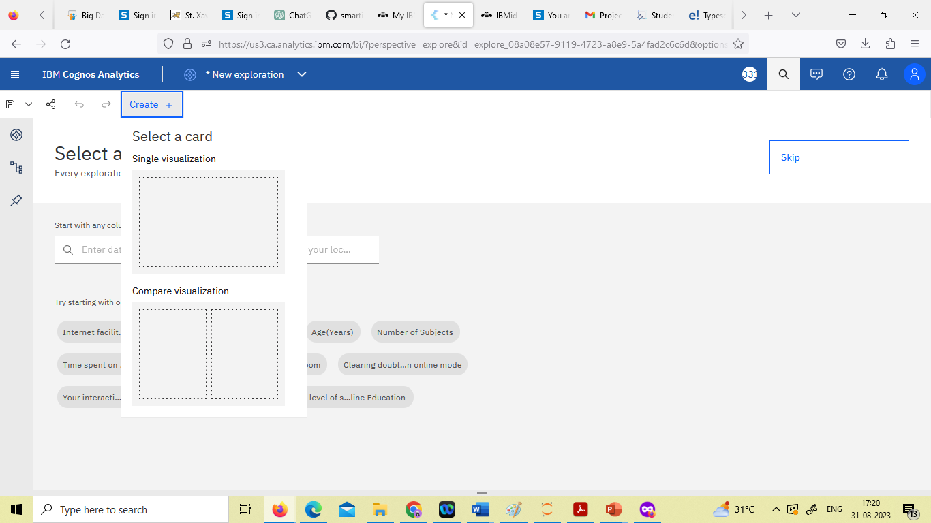

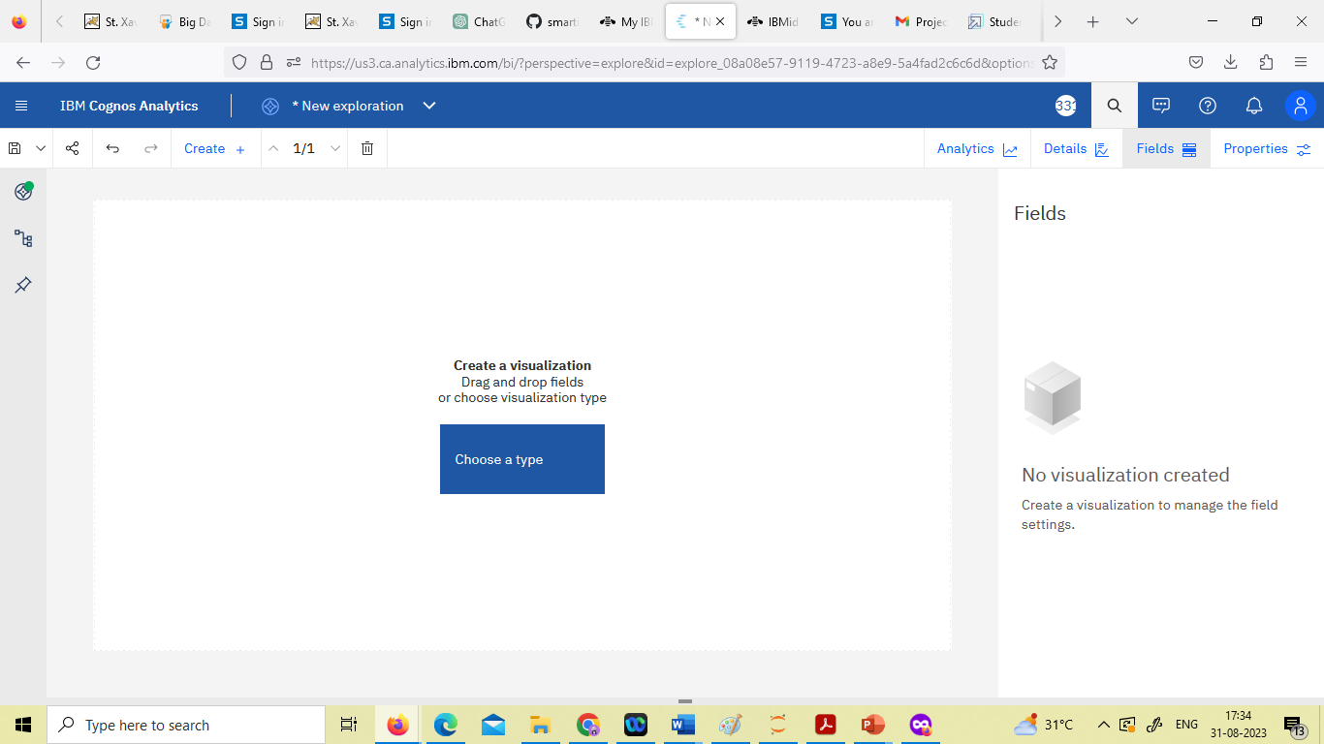

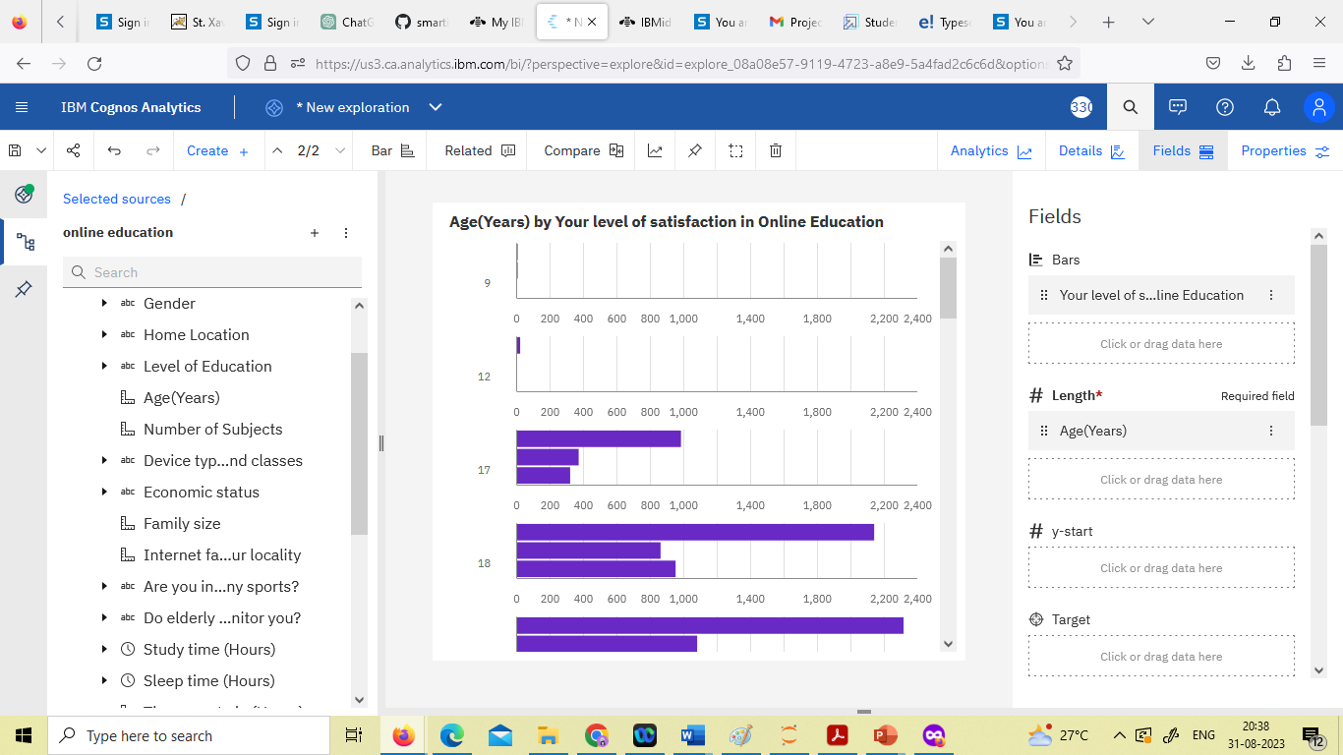

Across all values of Your level of satisfaction in Online Education, the sum of

Internet facility in your locality is over 3500.

Internet facility in your locality ranges from 850, when Your level of satisfaction in Online Education is Bad, to nearly two thousand, when Your level of satisfaction in Online Education is Average.

Internet facility in your locality is unusually high when Your level of satisfaction in Online Education is Average.

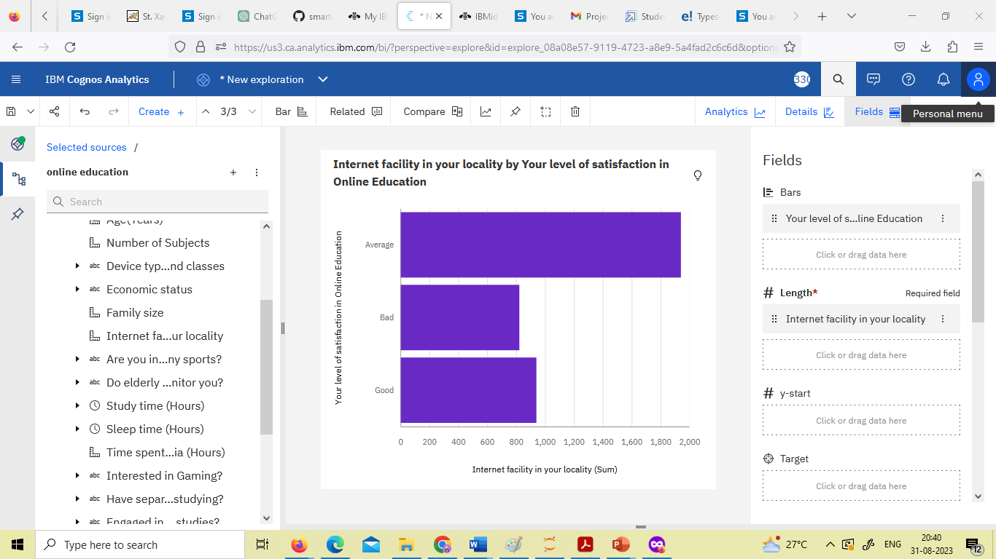

Over all values of Level of Education, the sum of Performance in online is nearly

seven thousand.Performance in online ranges from 565, when Level of Education is School, to nearly 5500, when Level of Education is Under Graduate.

Performance in online is unusually high when Level of Education is Under Graduate.

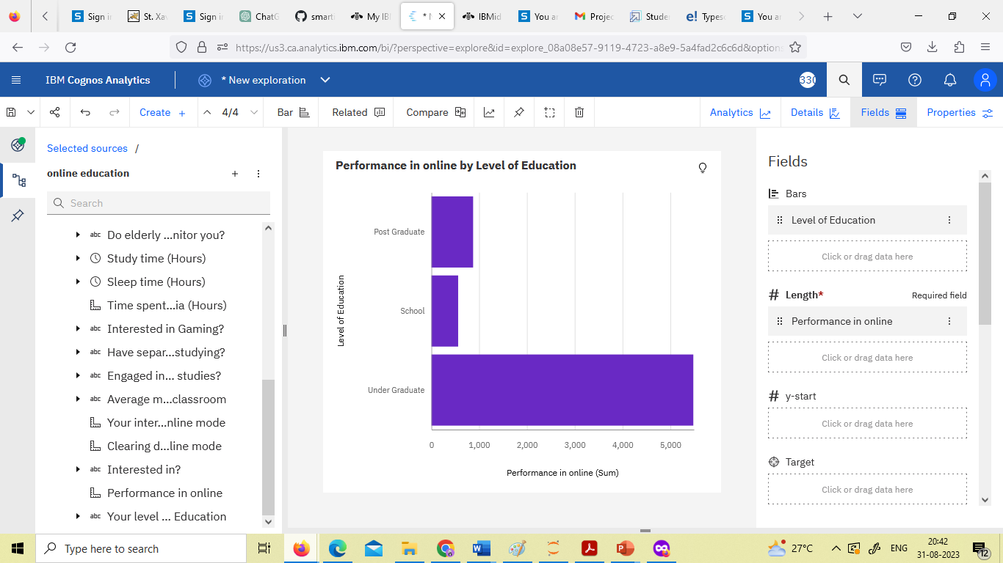

Across all device type used to attend classes, the sum of Time spent on social media (Hours) is over 2500.Time spent on social media (Hours) ranges from 71, when Device type used to attend classes is Desktop, to over 1500, when Device type used to attend classes is Laptop.Time spent on social media (Hours) is unusually high when Device type used to attend classes is Laptop.

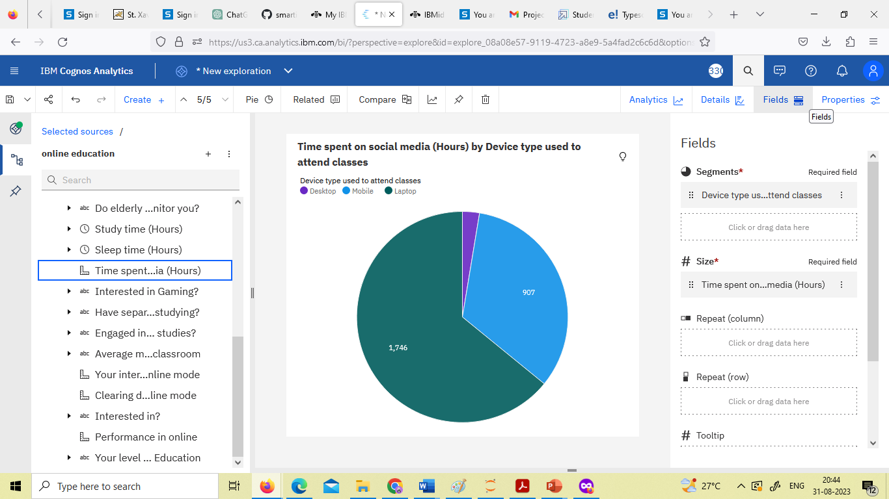

Over all values of Engaged in group studies? and Engaged in group studies?, the sum of Performance in online is nearly seven thousand.

The summed values of Performance in online range from nearly three thousand to

over four thousand.

Performance in online is unusually high when the combination of Engaged in group studies? and Engaged in group studies? is No and No.

For Performance in online, the most significant value of Engaged in group studies?

is No, whose respective Performance in online values add up to over four thousand, or 58.1 % of the total.

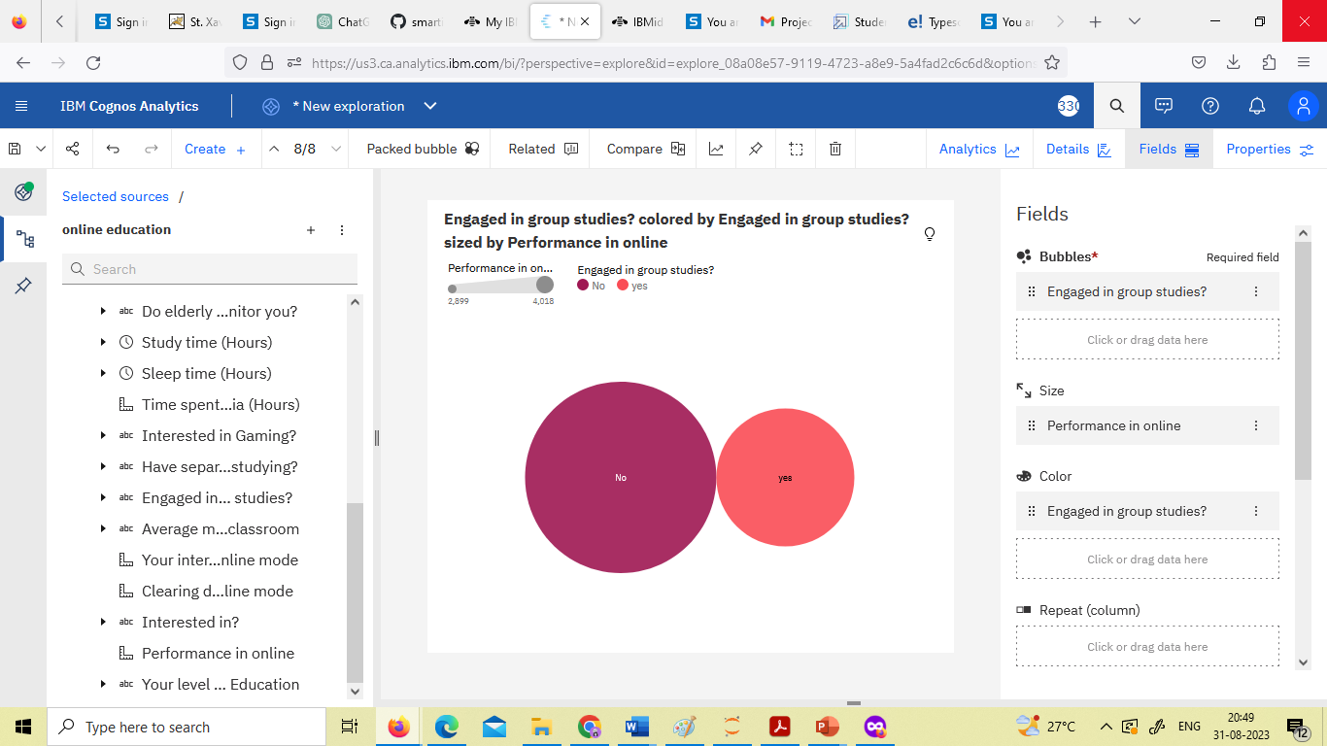

The total number of results for Average marks scored before pandemic in traditional classroom, across all average marks scored before pandemic in traditional classrooms, is over a thousand.

The counts are unusually high when the values of Average marks scored before

pandemic in traditional classroom are 81-90 and 71-80.

81-90 (33.2 %) and 71-80 (30.3 %) are the most frequently occurring categories of

Average marks scored before pandemic in traditional classroom with a combined count of 656 items with Average marks scored before pandemic in traditional classroom values (63.5 % of the total).

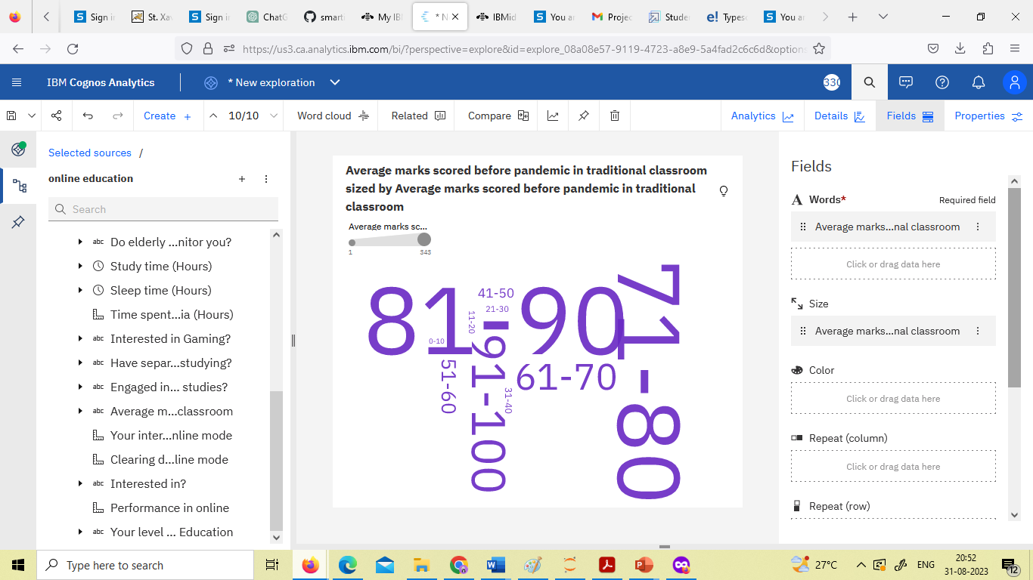

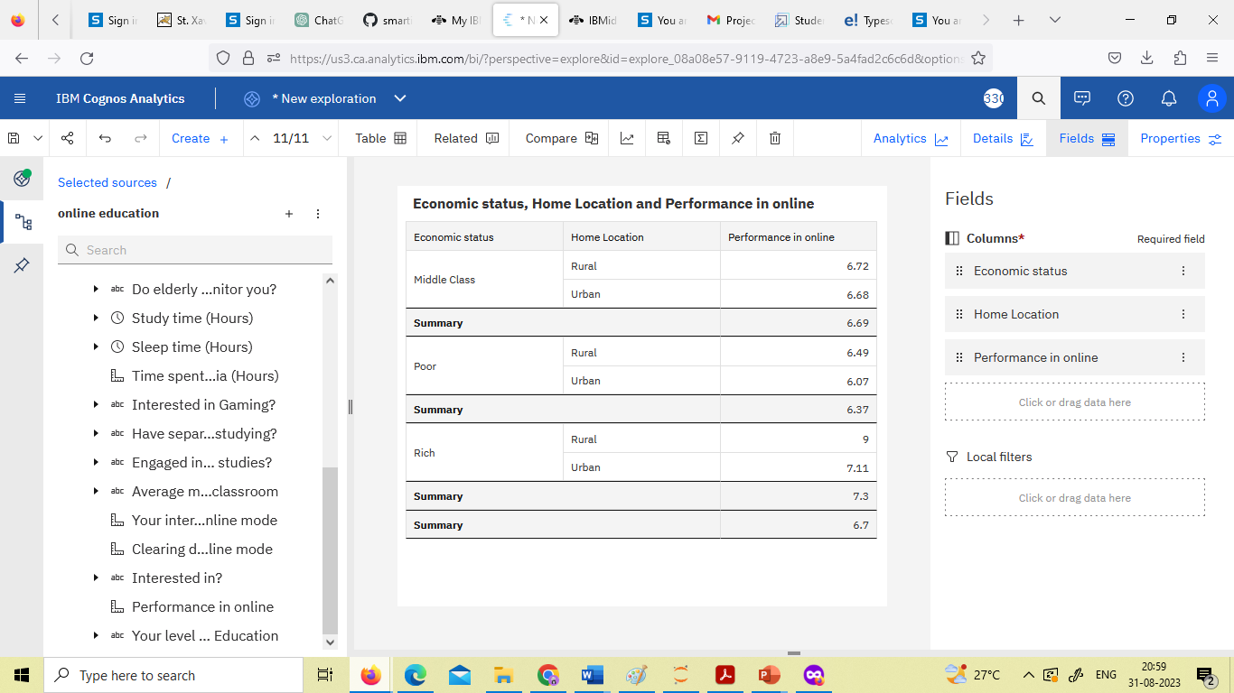

Over all values of Age(Years), the sum of Performance in online is nearly seven

thousand. Performance in online ranges from 4, when Age(Years) is 32, to over 1500, when Age(Years) is 20.

Performance in online is unusually high when Age(Years) is 20, 19 and 18.

For Performance in online, the most significant values of Age(Years) are 20, 19, and 18, whose respective Performance in online values add up to over 4500, or 67.6 % of the total.

